**GENTLE YOGA – Spring 2025**

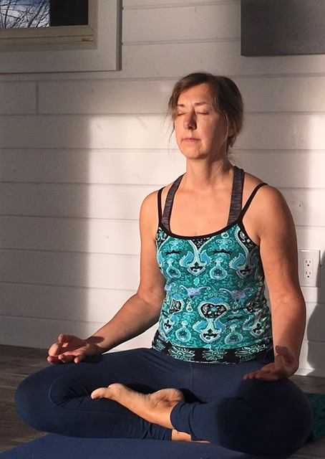

**Deborah Nordstrom, Yoga Teacher, RYT500, Brain Longevity Instructor**

Tuesdays, March 25 – April 29 (6 weeks); and Tuesdays, May 27 – June 17 (4 weeks). Sign up for one or both series!!

NEW Time: 9:00-10:00am

Cost:  $72 for six weeks  
$48 for four weeks  
$120 for 10 weeks

Bring your own mat.

Gentle yoga is a slower paced class that invites you to move gently and breathe easy, enabling you to relax your body and calm your mind.

Yoga is a Sanskrit word which means “to yoke” or “to unite.” Connecting the mind, body and breath has many physical, mental and emotional health benefits including improved strength, flexibility and balance, improved breathing, reduced stress, increased energy, and many more.

For more information: [Journey Fitness + Wellness- Yoga, Pilates, and Meditation](https://deborahnordstrom.ca/) or contact Deborah at (613) 558-7480 or e-mail [me@deborahnordstrom.ca](mailto:me@deborahnordstrom.ca)